**ASSIGNMENT**

SECTION 1: MULTIPLE CHOICE MULTIPLEEMULTIPLE CHOICE

1. Which of the following is NOT a component of the CPU?

1. ALU

2. RAM

3. CU

4. 1 and 3 both

(ANS= RAM)

2. What is the function of RAM in a computer?

ANS= The functions of ram in a computer are:

* Data storage: it is primary memory which stores data that the CPU needs to access quickly.
* Multitasking: more RAM allows better multitasking.
* Application startup: RAM allows for quicker application startup which reduce loading time.

3. Which of the following is a primary storage device?

1. HDD

2. SSD

3. SD card

4. 1 and 2 both

(ANS= No answer)

4. What is the purpose of a GPU?

ANS= Graphics processing unit (GPU) is a piece of hardware that’s responsible for rendering and displaying images, videos, and animation on a computer monitor.

SECTION 2: TRUE OR FALSE

5. True or False: The motherboard is the main circuit board of a computer where other components are attached. (True)

6. True or False: A UPS (Uninterruptible Power Supply) is a hardware device that provides emergency power to a load when the input power source fails. (True)

7. True or False: An expansion card is a circuit board that enhances the functionality of a component. (True)

SECTION 3: SHORT ANSWER

8. Explain the difference between HDD and SSD.

**HDD**

**SSD**

ANS=

* Read latency time very low.
* High reliability.
* SSD have no moving parts to fail.
* Small and light weight.
* Power consumption 2watts.
* Read latency time high.
* Low reliability.
* HDD have moving parts and subject to sudden failure.
* Relatively large and heavy.
* Power consumption 6-12watts.

9. Describe the function of BIOS in a computer system.

ANS= BIOS, or Basic Input/Output system, is a fundamental computer component that performs serval functions including:

* Booting
* Hardware initialization
* Data flow management
* Power-on-Self-Test (POST)
* System security
* Configuration
* Diagnostic tools

10. List and briefly explain three input devices commonly used with computers.

ANS= The three common input devices for computer are:

* **Keyboard**

A hardware device with keys for entering alphanumeric data, such as words, numbers, symbols, and commands.

* **Mouse**

A pointing device with a ball and buttons that allows users to click on icons to select them and open files or applications.

* **Microphone**

A device that converts sound into a digital or electrical form for input into a device.

SECTION 4: PRACTICAL APPLICATION

11. Identify and label the following components on a diagram of a motherboard:

● CPU

● RAM slots

● SATA connectors

● PCI-E slot

ANS=

RAM Slots

CPU

PCI-E-slot

SATA connectors

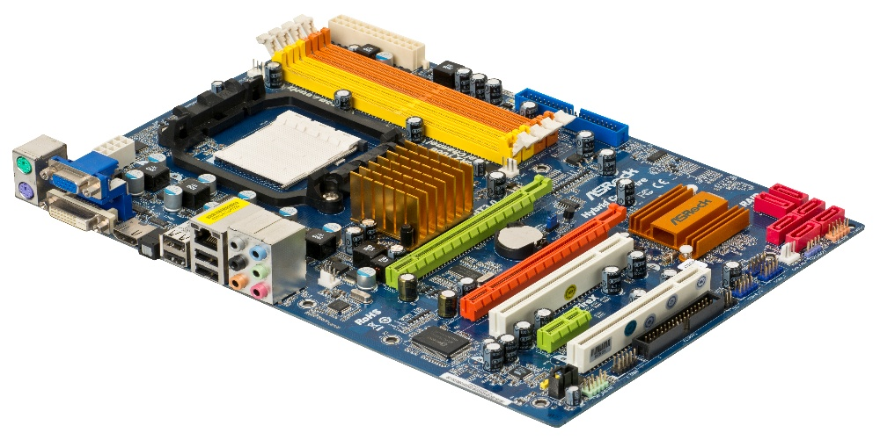

12. Demonstrate how to install a RAM module into a computer.

ANS= There are some steps to install a RAM module into a computer:

1. Power off and ground yourself
2. Locates the RAM slots
3. Release the clips
4. Align the RAM
5. Insert the RAM
6. Press down
7. Reassemble
8. Check

SECTION 5: ESSAY

13. Discuss the importance of proper cooling mechanisms in a computer system. Include examples of cooling methods and their effectiveness.

ANS= A proper cooling system is important for a computer system because it helps to:

* **Maintain performance**: Heat can degrade the performance of a computer's internal components, such as the CPU and GPU. A good cooling system keeps these components within safe temperature limits, which is important for tasks like gaming and video editing.
* **Extend lifespan**: A faulty cooling system can shorten the lifespan of a computer.
* **Prevent damage**: A faulty cooling system can cause serious damage to a computer's hardware.

Some examples of computer cooling systems include:

* **Air cooling**

Uses fans to blow air over heat sinks, which are metal blocks attached to components that generate heat.

* **Liquid cooling**

Uses water blocks, a pump, a radiator, pipes, and optionally a reservoir. Liquid cooling is considered one of the best ways to cool a computer because of water's high thermal conductivity.

* **Laptops**

Laptops typically use sophisticated air-cooling systems designed for their smaller chassis.

Other cooling techniques include:

* Liquid immersion cooling
* Waste heat reduction
* Heat-sinks
* Peltier (thermoelectric) cooling
* Heat pipes and vapor chambers
* Electrostatic air movement and corona discharge effect cooling
* Soft cooling

14. Explain the concept of bus width and its significance in computer architecture.

ANS= Bus width in computer architecture is **the number of bits that a bus can transfer per clock cycle**. It's also the number of physical electrical conductors on a bus, if each conductor transfers one bit at a time.

**Bus width is important because it determines how much data can be transmitted at once, which affects a computer's performance:**

**Data bus**

The width of the data bus determines how much data can be transmitted between the CPU and memory or between different components. A wider data bus means faster data flow and better system performance.

**Address bus**

The width of the address bus determines the maximum amount of memory a system can address.

**Other types of buses in computer architecture include:**

* **Control bus**: Carries control signals that manage and coordinate activities between various components.
* **System bus**: A collective term for the address bus, data bus, and control bus.